**Users / Role:**

1. **Admin**
2. **Exam in charge**
3. **Exam staff**

**Description: Various components of created exams**

|  |  |  |  |
| --- | --- | --- | --- |
| Sl No | Activity | User | Remarks |
| 1. | View of exam components of all created exams | Admin, exam staff |  |
| 2. | Creation of new exams with various components like Exam code, Exam type, Sem exam Type | Admin, exam staff |  |
| 3. | Display available exam Categories | Admin, Exam Staff |  |
| 4. | Assign particular exam categories | Admin, Exam Staff |  |
| 5. | Select subject weightage parameters  L:lecture, P:practical, T:tutorial, etc… | Admin, Exam Staff |  |
| 6. | Modification of created exams | Admin, Exam Staff |  |
| 7. | Delete created exams | Admin, Exam Staff |  |
| 8. | Save Changes | Admin, Exam Staff |  |
| 9. | Search exam dropdown | Admin, Exam Staff |  |
| 10. | Browse through created exams | Admin, Exam Staff |  |

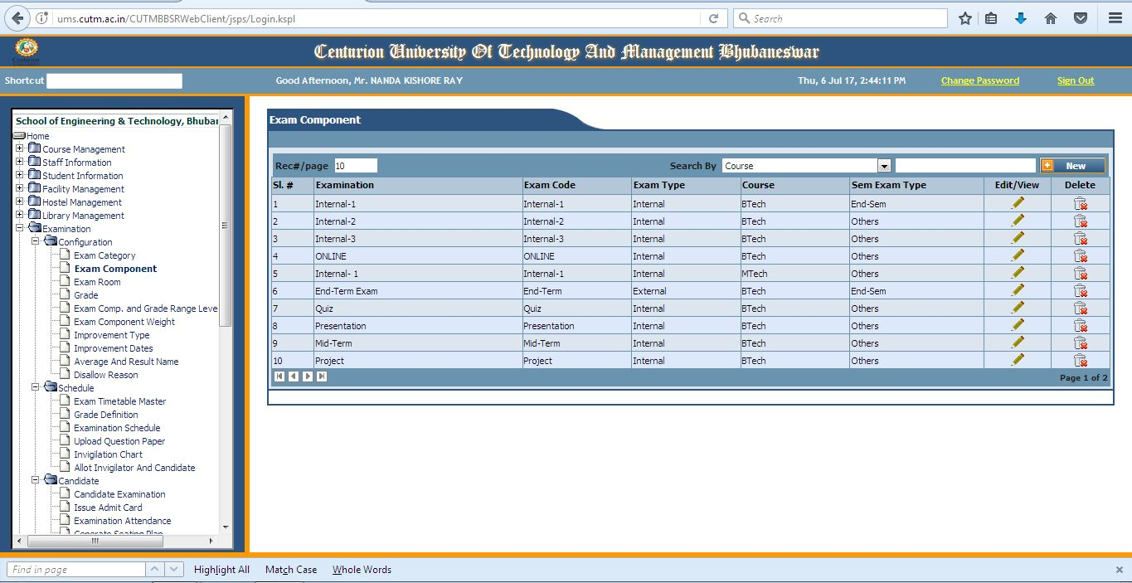

* In this page of exam component we view and browse through exams.
* We have an option of searching previously created exams.
* We can modify previously created exams.
* We can delete created exams.

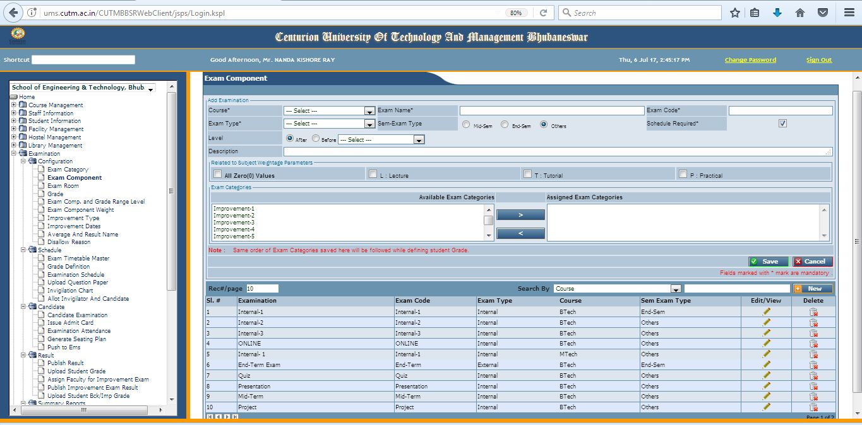

* This page is dedicated for creation of new exams by adding various components like exam code, exam type, …
* We can assign the earlier created exam categories to the newly created exams.